INSTRUCTION SHEET
Screencast-o-matic
- Click http://www.screencast-o-matic.com/
Main page
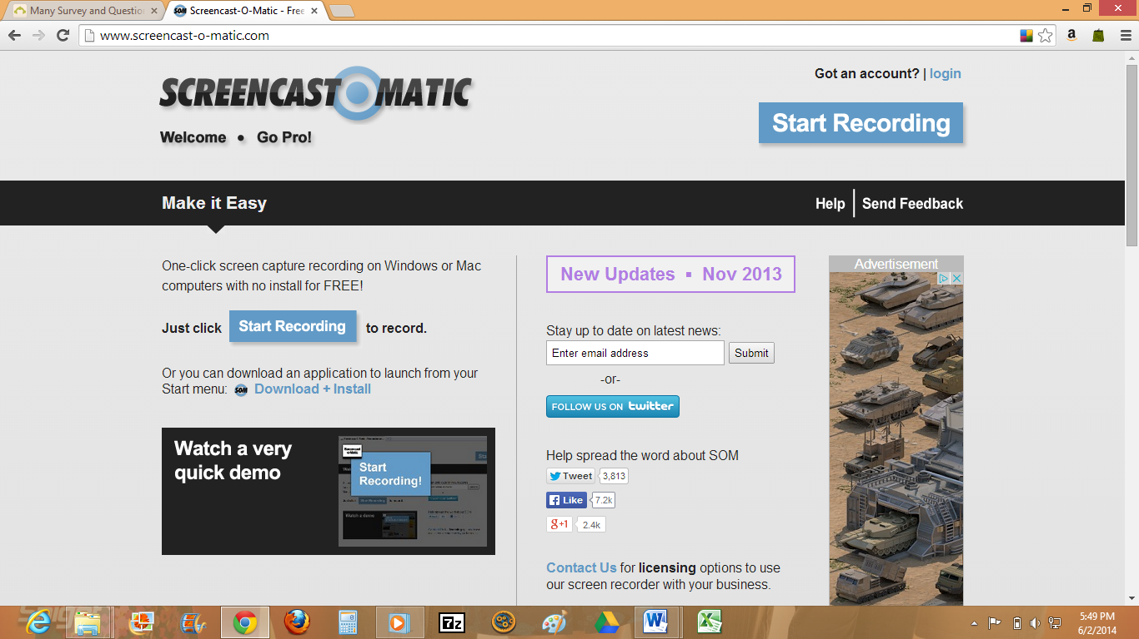
- Open myExperiment at http://www.myexperiment.org/
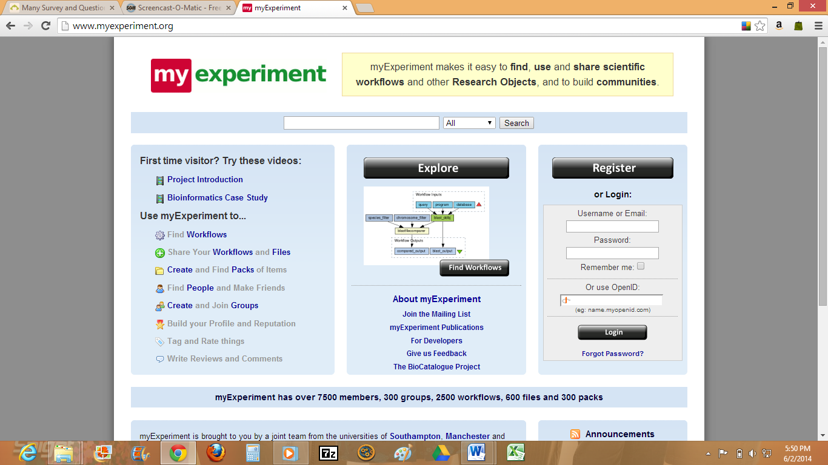
- Go back to Screencast-o-matic page and click ‘Start Recording’ button
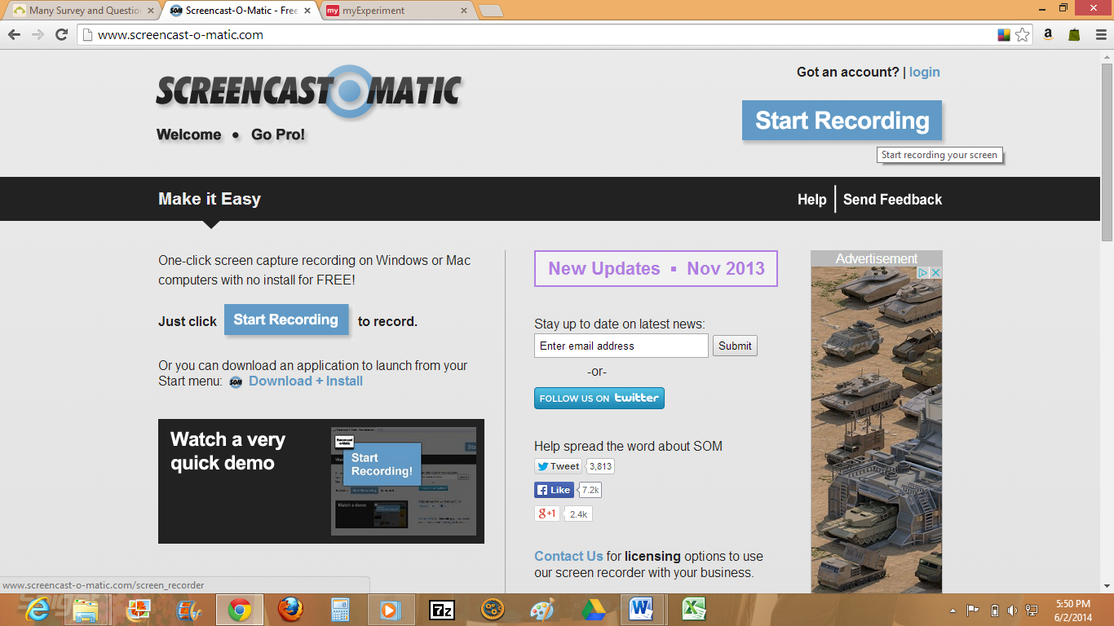
- A Java runtime prompt will appear. Click ‘Run this time’. Screen Recorder will begin loading after that.
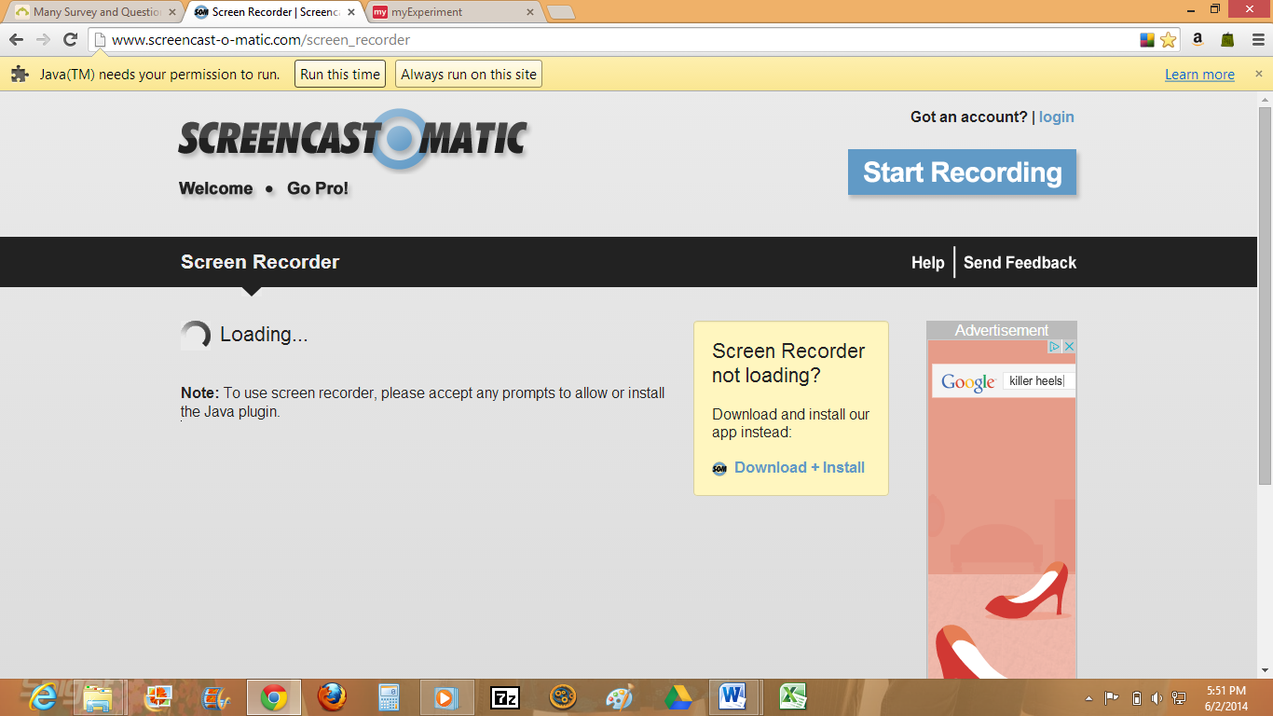
- Click ‘Run’
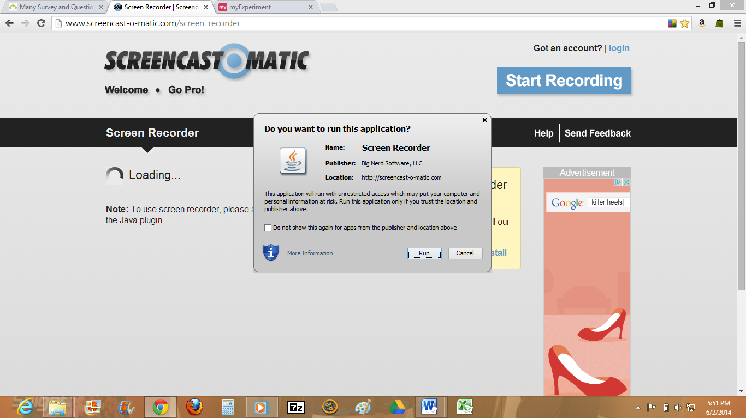
- A screencast frame will appear on screen. Point cursor to the corner of the frame to resize and fit the full screen
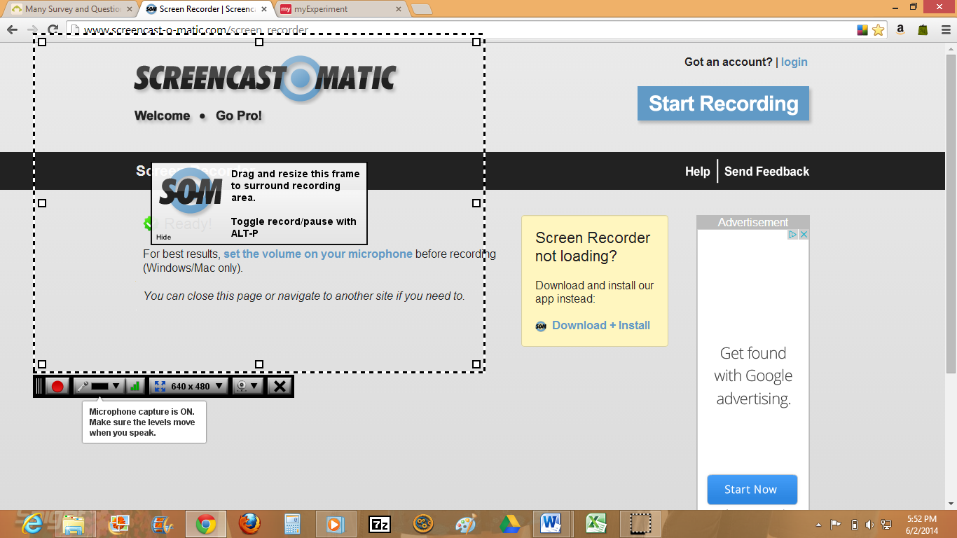
- Switch to myExperiment page
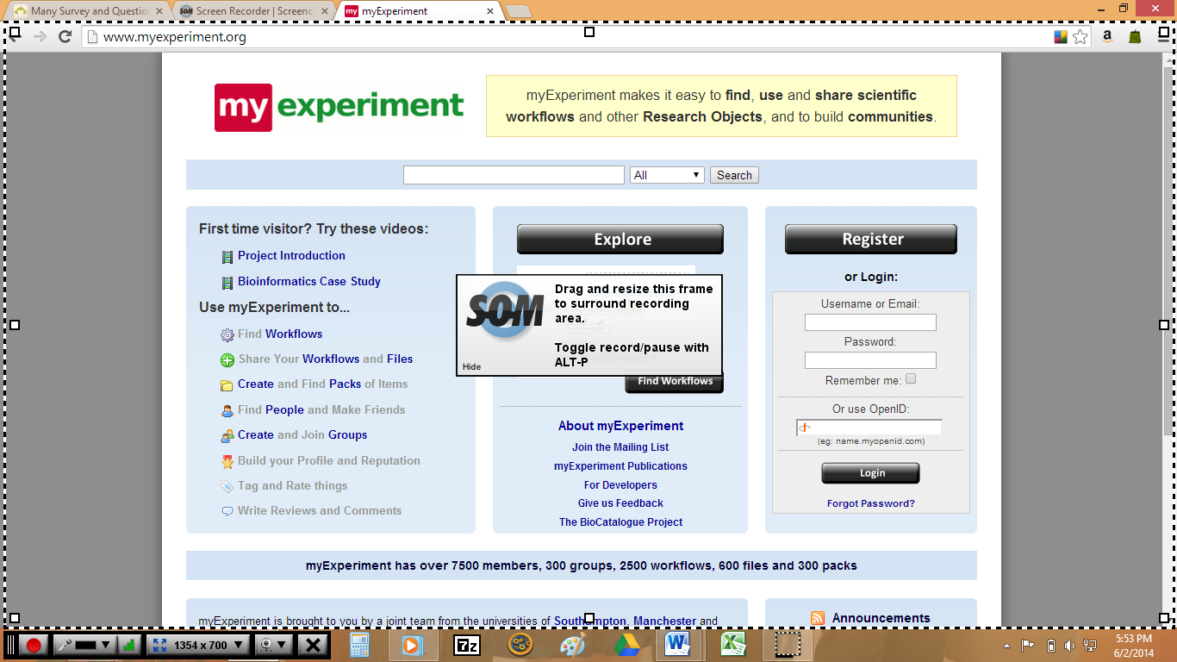
- Click the ‘Start Recording’ button at the bottom of the frame to begin recording your session. The control panel appears at the bottom of the frame. Please check that the microphone capture is on

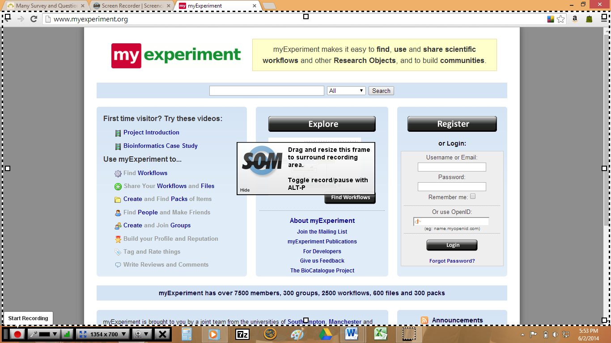

- After clicking the start recording button, a countdown screen will appear. Wait until a red border frame appears which will indicate the screen is being recorded.
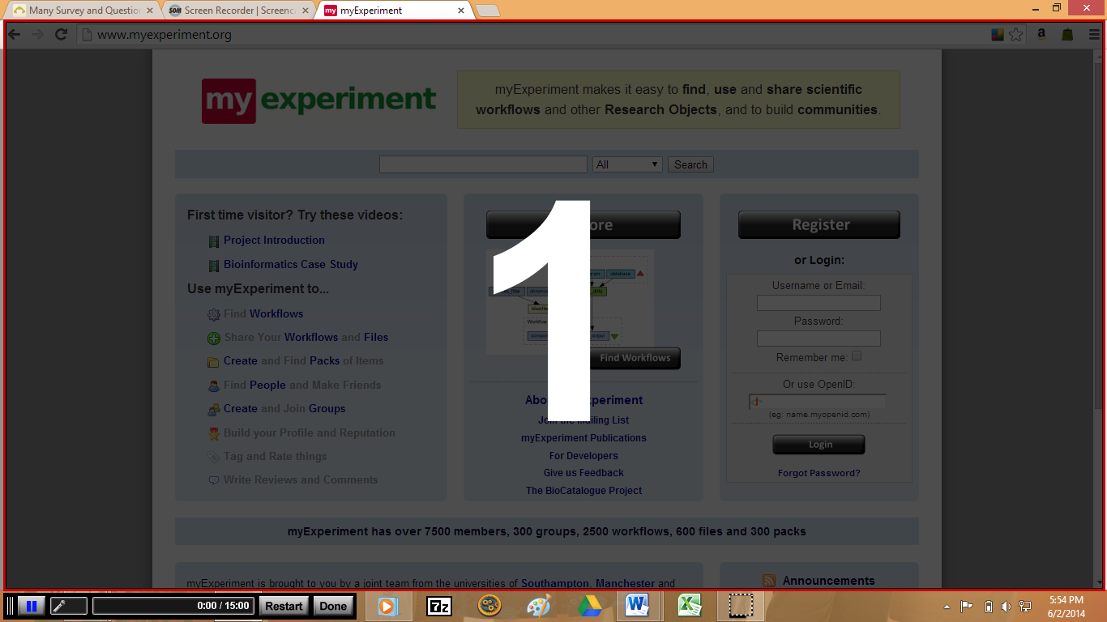
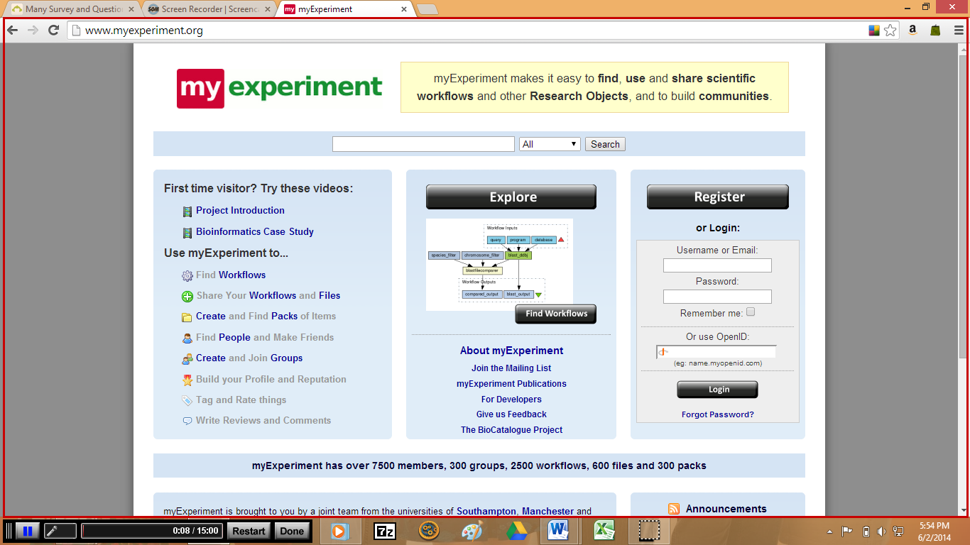
- After you have finished recording your session, please press the ‘Done’ button. If you would like to pause in between you may press the button.
- After pressing ‘Done’ the Preview page will open. Choose ‘Publish to Video File’ to save the recording.

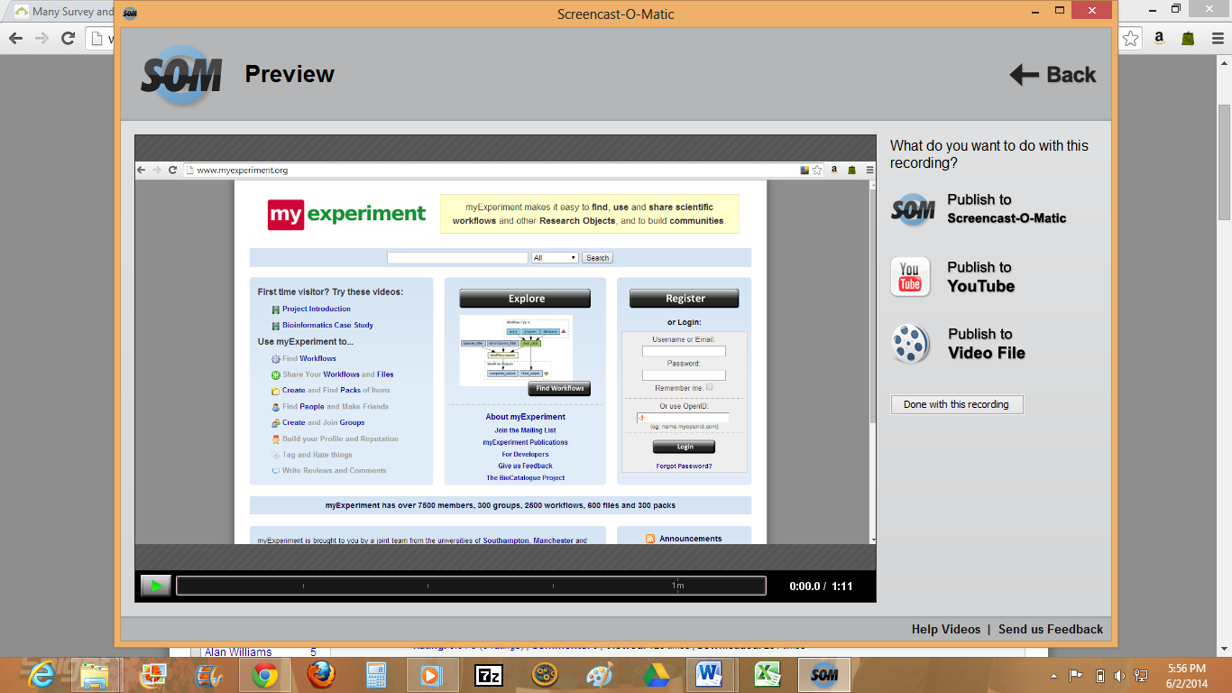
- Choose Video Type: Quicktime (MP4) or Windows Media (AVI) and Screen Size: Full screen. Then click ‘Save Video’
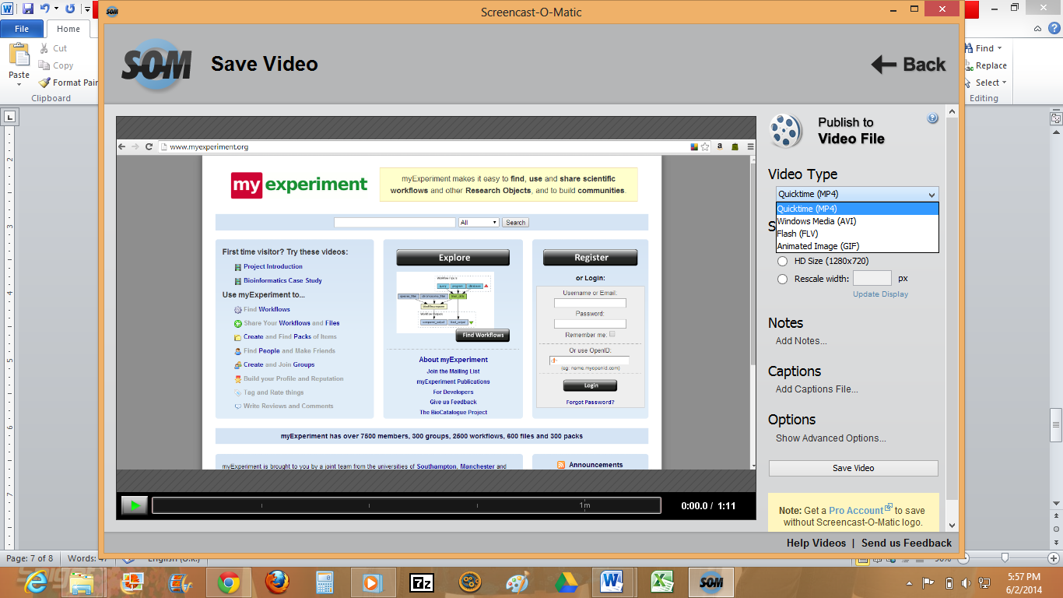
- Name and Save your file.
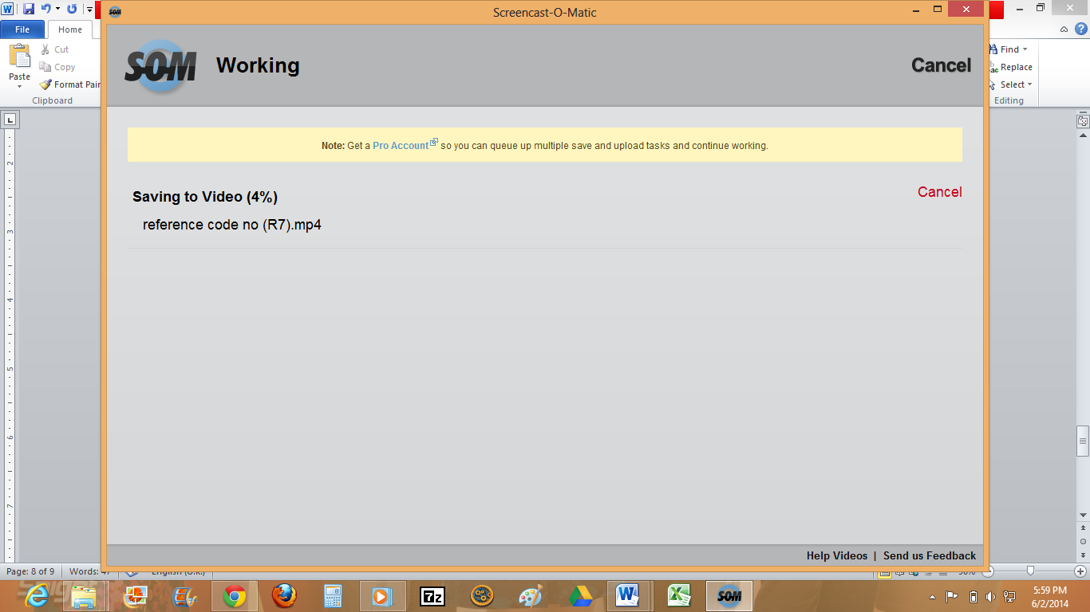
- Completed file has now been saved in chosen format.
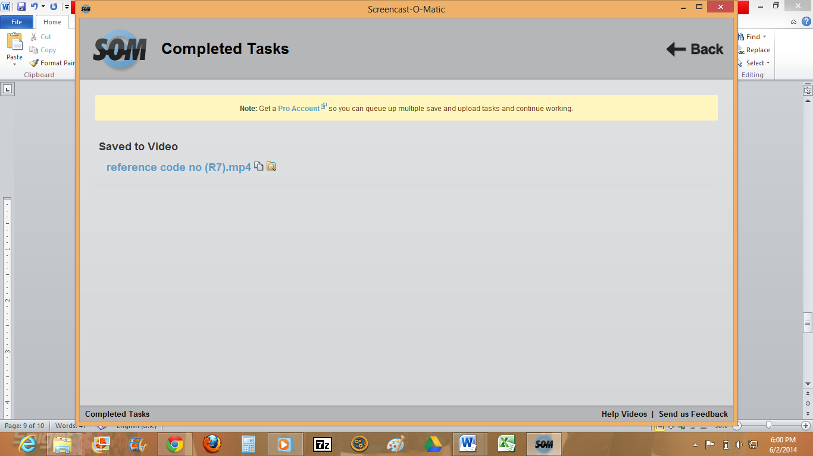
Note:
- Each recording session using screencast-o-matic is limited to 15 minutes. If you’re recording is longer you may start a new recording from where you previously stopped (repeating the steps above)

Skype
- Sign in to skype https://login.skype.com/
- Evaluator will make a video call on scheduled date and time with participant
- If participant would like to post questions / comments or chat in between session, they may do so through video messaging, instant messaging.
- If you would like to, you may share your computer screen with the evaluator using screen sharing feature.

To share your screen:
- Open the Skype window and sign in.
- Make a voice call or video call to one of your contacts.
- Click the + button in the call window, then choose Share screens.
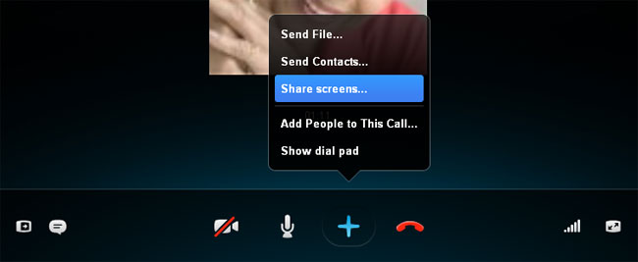
- The other person will be able to see live video of what's on your screen, including your desktop and any programs that you may have open. Below is an example of what it will look like from your contact's point of view.
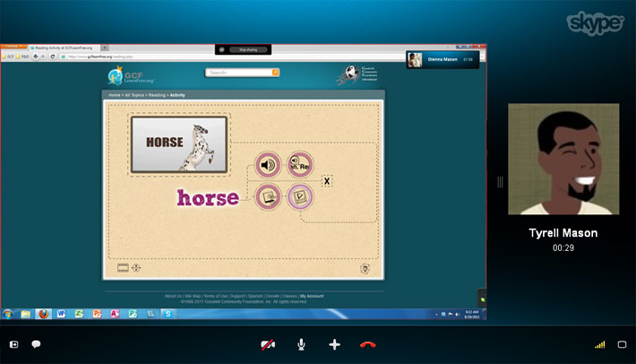
- To stop sharing your screen, click the Stop sharing button.
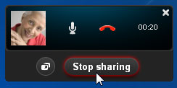

Camtasia Studio 7
- Use installation file provided to install software
- Main screen will appear as:
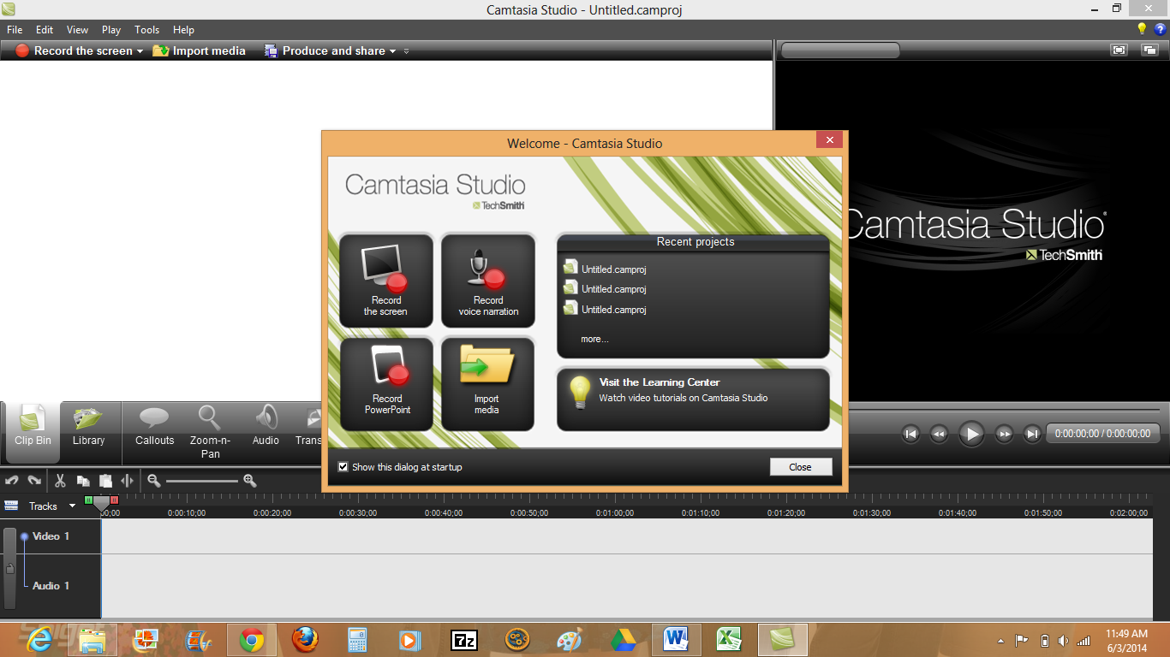
- Click Record the screen. A control panel will appear at the bottom right corner of your computer screen

- Open myExperiment at http://www.myexperiment.org/
- Open the control panel and press ‘rec’ button to begin recording

- A countdown screen will appear followed by a control panel at the bottom right of your computer screen

- After you have finished recording, you may press the stop button. This will be followed by a preview screen. Click the ‘Save and Edit’ button to save your file

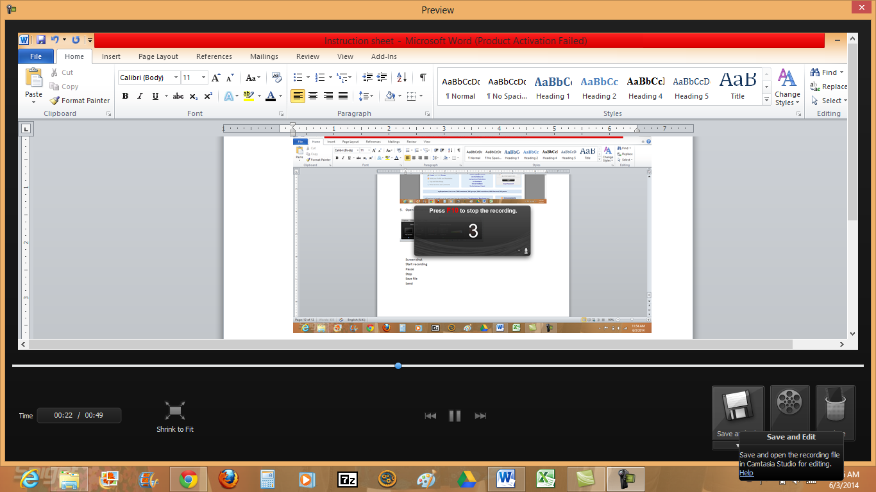

- Save your file with the .camrec extension. Click Save. A dialog box for size option with a default size will appear. Press OK. Click X
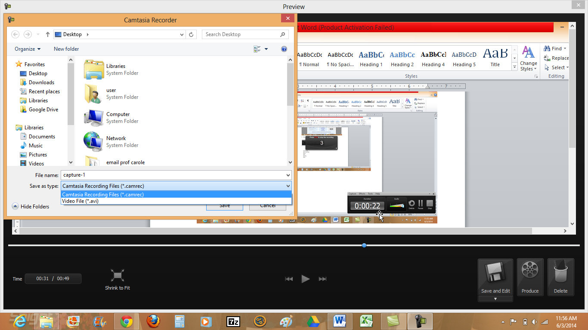

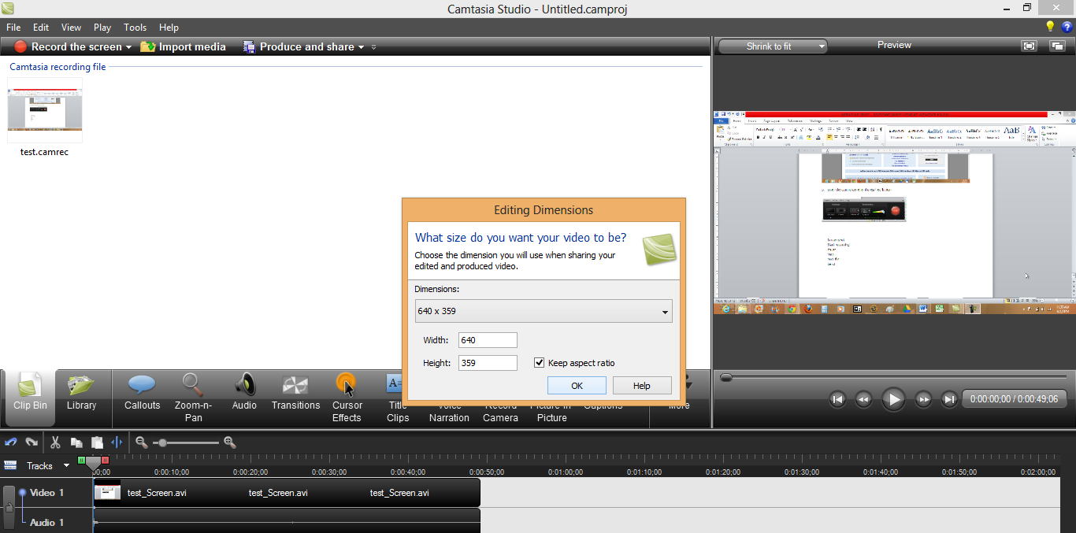

- A save changes dialog box will appear. Choose Yes

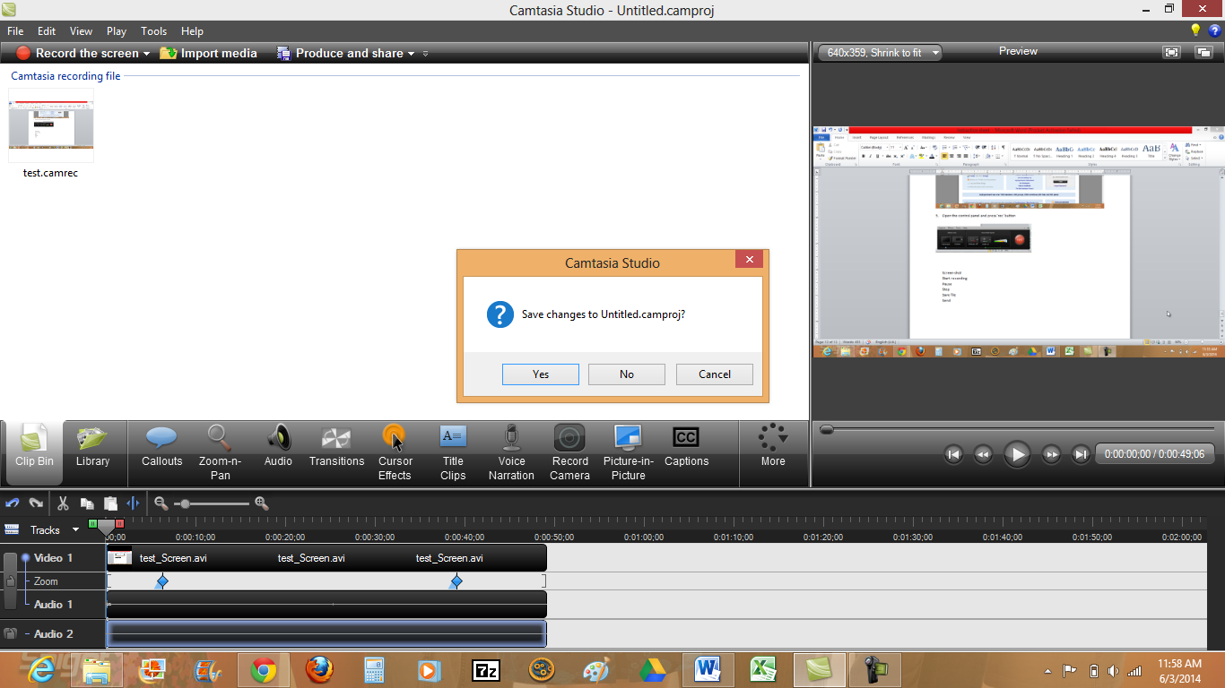

- Name and save file. Press OK

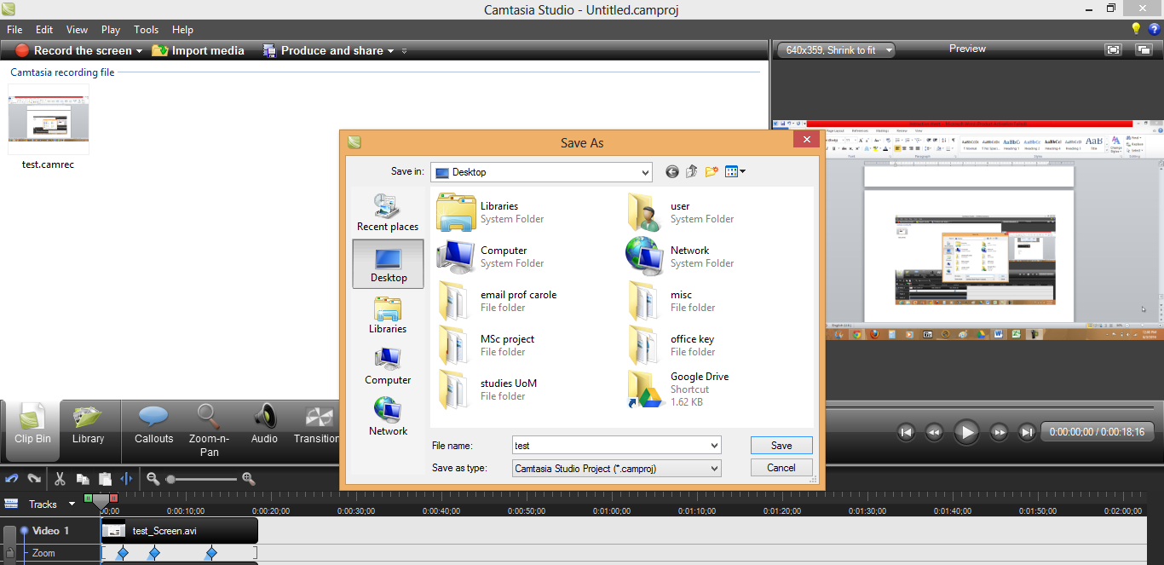

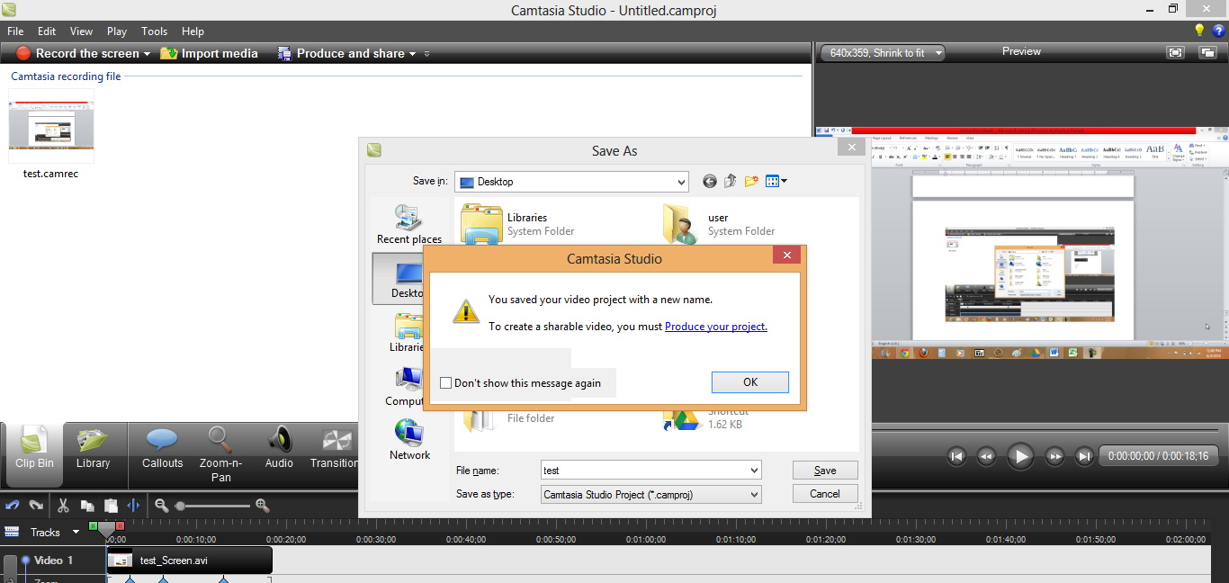

- The final saved file will appear in 2 formats:

