The fight against aesthetic pollution - marketing funds for urban restoration.Cooperation between the private and public sector to improve the urban environment.

Kopsidas Odysseas ^{1*}, Fragkos-Livanios Leonidas.²

- Department of Agricultural Technology, Technological Educational Institute of Thessaloniki, 17thKm Thessaloniki-Sindos, 57400, Thessaloniki, Greece.
- Division of Natural Sciences and Applications, Hellenic Army Academy, 16673, Vari, Attiki, Greece.

*Corresponding author: E-mail: odykopsi@yahoo.gr.

.
Abstract

The purpose of this study is to present a modified model of internalizing external costs caused by the operation of a manufacturing unit in conjunction with a new reality created. The environment is characterized as a public good.
We suggest a novel marketing approach operating within legislative restrictions such as the prohibition of outdoor advertising in a city environment. The case examined is the city of Athens. Contingent Valuation Method and expert opinions were used to evaluate the effect of aesthetic pollution and estimate the potential of our proposal. The proposal describes an exemplary collaboration between private and public sector that brings multiple benefits without burdening any social group, on the basis of a Pigouvian subsidy scheme for renovation of city building facades, including motive to encourage advertising on the scaffoldings used for the renovation (which is allowed by law). Advertisers will place advertising screens on the scaffold while revenues from advertising will fund the renovation of the facade of the building. The suggested solution combines two seemingly competing activities of the city, outdoor advertising and the aesthetic reconstruction of building facades. Activity is transferred from micro to macroeconomic level, while at the same time Pareto criterion of optimality is met.

Keywords: Aesthetic Pollution, Contingent Valuation Method, scaffolding advertising, restoration

- INTRODUCTION

Outdoor advertising is an activity that causes aesthetic (Flad, 1997) as well as material pollution (posters, billboards, sticker material etc.). In Europe alone there are between 2 and 8 million billboards displayed at any given time and this number is constantly growing. Every 2 weeks, over 6 million square metres of poster paper are thrown out. The paper is not recycled, the ink is not eco-friendly, and the glue used is toxic (ECOBOARD, 2014). Due to this, billboard advertising has a disastrous effect on the environment, and this issue needs to be addressed. The negative effects are pronounced on large urban centers, such as Athens. For many years the Greek Capital faced the problem of unrestrained advertising. The situation led to a legal ban and final dismantling of outdoor advertising. Businesses and advertisers no longer find legally physical space to display their products.One way out is the online advertising. The online advertising however does not fully cover the needs of the advertiser since a number of social groups (eg the elderly) have no - or limited at best- access to electronic technology. Consequently, the justified concern for aesthetic enhancement deprived the possibility of advertising to businesses and led to income loss for dozens of employees.
On another note and completely unrelated to the above, the aesthetic state of the city of Athens is scarred by the poor condition of the facades of a great number of private or public buildings. The dark gray and black color (literally) dominates the streets of large areas of the city, creating an atmosphere of depression. On certain streets sunlight is 'stifled' between 'black buildings'. Many buildings of great architectural value lay convicted under the 'gray' pollution accumulated over decades. There is a strong relationship between the perceived lightness of a building and the opinion that it is dirty (Brimblecombe&Grossi, 2005). Blackening of light coloured fabric eventually reaches a point where it becomes publicly unacceptable and raises pressure for cleaning (Hamilton and Mansfield, 1992).This aesthetic, more specifically, this visual pollution has an important -albeit undefined- cost to the social and financial life of the Greek capital.
A relevant subsidies program with the name ‘ΠΡΟΣΟΨΗ’ ('Facade') was put in place by the Municipality of Athens. The aim of that program was the improvement of the city’s general aesthetic. The effect of this effort was negligible, with the vast majority of the affected buildings remaining in this plight. In the mind of the public, external renovation of buildings is a difficult or even impossible goal. Planning authorities have a statutory responsibility to plan for the sustainable development of their areas, primarily through the development plan process but also through local area plans. Nonstatutory framework plans and site development briefs can supplement but not replace the function of statutory plans (Government of Ireland, 2009).
- FORMULATION OF THE PROBLEM
Building darkeningdue to particle deposits is up to a point a negative externality, since the property owner is not responsible for the air pollution which is a major factor of the process. From the other hand, fouling due to time passing, as well as damage and corrosion has to be dealt with by the land owner. The end result is an aesthetically polluted neighborhood and -by extend – city. This pollution affects functionally and financially the city, thus becoming a negative externality itself from the city’s point of view. Being hard, even impossible to pinpoint the responsible for this externality, the burden for its internalization is left mainly on the land owners and in many cases they are just not willing – or simply cannot afford- to pay, leading to total or partial neglecting of the necessary restoration.
Outdoor advertising on streets, building walls and terraces, is prohibited by law in Greece. This caused a crucial blow to an already struggling sector, especially the last 5 years of recession and led to job losses and shrinkage of the industry.
The arguments against outdoor advertisement traditionally have followed an aesthetic narrative with varying degrees of success in terms of restricting the proliferation of billboards. The public has consistently found outdoor advertising to be intrusive, ugly, crassly commercial, and a taint on nature. With billboards being an emblematic tool of the industry and marketing, the story of outdoor advertising is an ongoing struggle between an expanding industry and a resistant public. Signs are affecting seriously the visual environment of a city. They are prominent structures that are typically, and deliberately, highly visible in the public. From their first appearance in the late 19th Century through today, billboards have met resistance on aesthetic grounds. Flad (1997) comments that “…they [billboards] also do not perform an effective function. They simply encourage consumption’’.
Historically, the regulation of outdoor advertising has prompted a surprisingly prodigious amount of controversy and litigation. It has been challenged as a denial of free speech, due process and equal protection. It has been upheld on nuisance and real property grounds, and sustained on the basis of public health, safety, morality, comfort and convenience, aesthetics and the right to be let alone (Shutton, 1972). The argument against outdoor advertising which appears most often focuses on billboards’ adverse visual and aesthetic impact on the surrounding community. Advertising billboards are openly accused for “visual pollution” and how they “desecrate the landscape” (Flad, 1997).
In a study regarding the impact of billboards on real estate prices in the City of Philadelphia, USA, (Snyder, 2011) it was revealed that properties purchased within a small radius of billboards have a significant decrease in sale price and the correlation is statistically significant (p ≤ .05). Further,the analysis reveals a correlation between billboard density and home value. Billboards negatively impact home values.
There is compelling evidence that distraction is a major contributor to crashes (Lee, McElheny and Gibbons, 2007; Wang, Knipling& Goodman, 1996; Stutts et al., 2001; Klauer et al., 2006). The studies that have been conducted show convincingly that roadside advertising is distracting and that it may lead to poorer vehicle control. However, the evidence is presently only suggestive of, although clearly consistent with, the notion that this in turn results in crashes. Studies providing direct evidence that roadside advertising plays a significant role in distraction based crashes are currently not available. A review by Austroads (2013) identifies the issue of distraction due to roadside advertising but suggests that it is reasonable to conclude that far less than 1% of all crashes and near crashes involved distraction from roadside advertising.

2.1. Methodology
2.1.1. Contingent Valuation Method
In this research, the Contingent Valuation Method (CVM) was used (adapted by Mitchell & Carson, 1989). Questioners were distributed to residents of selected neighbourhoods of Athens, in order to estimate their willingness-to-pay to support restoration projects on their neighbourhood and other areas in central Athens. The questioner format aims to probe the general attitude of citizens on restoration projects and extract quantitative data in monetary units on how they value abstract ideas such as visual pollution. Additionally, it screens citizen preference on alternative strategies for urban environmental improvement. Preferences of people are examined by asking people directly their WTP or WTA a change in environmental quality.
The survey is part of an on-going wider study regarding the aesthetic pollution of the city. Since it is not formed to investigate solely the idea presented here, the quantitative data analysis is out of the scope of the present work and therefore is not presented. We present only qualitative conclusion on ‘discomfort levels’ due to aesthetic pollution from building facades darkening and an estimate on WTP/WTA.A representative questioner sample can be seen in Appendix A, along with the answer results from a specific neighbourhood.
2.1.2. Getting expert opinions
To acquire the views of experts in the fields of advertising and real estate market, telephone interviews were conducted.
Six (6) professional advertisers were interviewed. Specific questions were addressed. Advertisers were questioned whether they would be interested to advertise on scaffolding if it is legal and if there is a relevant municipal program in place for the restoration of building facades, what would be the amount considered reasonable to allocate for the period that the restoration will last according to the size of the building and the time (for example, a seven-storey building with a width of 15-20 meters and for one month), what type of advertising they consider most appropriate for scaffolding (general commercial or industrial) and finally asked what was their opinion on the operation of such a venture.
Eleven (11) realtors were interviewed. They were asked on the real estate price trend on specific areas in Athens and Kozani, before and after restoration or improvement project on the area. They were asked on the importance of the facade state and how it is affected by darkening.
- TOWARDS A SOLUTION OF THE PROBLEM
3.1. Results
Regarding the CVM questioners, the answers show two seemingly contradicting trends. The majority of residents are annoyed by the visual pollution in their neighbourhood and believe that restoration programmes are the key to the solution. They seem, however, not willing to pay -or at best, willing to pay very little (around 20-30 euros each in average) - for the improvement of the aesthetic of their environment.
The questioner presented in Appendix A is a representative sample. From the questionnaire circulated in the area of Thisio, respondents were separated by gender, age, whether working at the aesthetically affected area or not, whether residing or not at the aesthetically affected area, whether they own real estate properties at the affected by aesthetic pollution area. We then applied Variance Analysis. The dependent variable is the amount of WTP. Independent variables are the nominal variables of the questionnaire. In a brief the results can be summed up as follows: WTP is dependent by age, respondents consider that effective treatment of aesthetic degradation will substantially benefit professionals (73% positives) and residents on the area, the impact of the renovations would be significant, they would have a practical benefit from a concerted effort by the municipality and citizens to address the aesthetic pollution (Great benefit 33%. Moderate 36%, Small 31%) and yet, in the absence of funding, respondents were willing to pay only 19.71 € in average.
On the other, advertisement experts, after admitting that outdoor advertisement is aesthetically unpleasant but it was (and still is in some cases albeit illegal) a substantial percentage of their income, were in general positive to the idea of scaffolding advertisement. Two of them suggested that electronic screens are the best way to go, since moving images attract more public attention. They raised concerns regarding the cost, considering that the restoration of a seven-storey building façade (working example) will last roughly a month and would cost 12000 euros or more. They unanimously agree that the endeavour would be successful only if a relevant municipal scheme is put in place, organising the activity, offering support in the form of a subsidy and buffering any ‘price war’ that might arise between marketing firms, something that would cut out small firms from the deal.
Realtors unanimously verified the hypothesis that aesthetic degradation of a location leads inevitably to lower market value of the neighbourhood properties. The opposite happens when the aesthetic value of the location is improved by restoration projects, with the land property prices following an upward trend. They generally agreed that properties next to billboards or on neighbourhoods that unrestricted outdoor advertising is in practice have lower prices. They unanimously agreed in the most emphatic way on the positive correlation between the price of the property and the appearance of the building facade, especially the shading of the colour. As one realtor said: “no one will buy a flat on a dirty building”,proving that in his mind a darkened façade implies an overall unclean building.
3.2. Aesthetic pollution and urban restoration.
The valuation of aesthetic pollution from buildings in the centre of Athens can be made with the tools offered by the Environment Economics. Environmental Economics, as a branch of economics, has a parallel course to the general economic theory at least since the 18th century. Each resource alone or in combination with others can be used in alternative ways. The problem that arises is how natural resources are distributed optimally on options presented. To establish a conceptual framework for our working hypothesis, we assume that environmental issues are basically microeconomic problems (discussed in Tye, 1985; Kinnaman, 2013). Consequently, their examination involves the use of basic concepts and analytical tools of neoclassical microeconomic theory. Any suggested plan must satisfy the principles of sustainable development: Financial, social and environmental sustainability.
The trend of area redevelopment first appeared in Western European metropolitan areas, particularly at cities with heavy urban heritage and fewer suburbanization tendencies. In the late 60s the demand for maintaining / upgrading of the cultural heritage in cities or regions with strong historical character was vocalized. At the same time, existing models and methods of urban development were challenged (Loures, 2015). At that period the renovation of the Jordaan district in Amsterdam and Harlem and VINGO in Stockholm began. In North America, an area with lighter urban tradition, the reuse of central areas for housing occurs largely combined with the questioning of the suburban model from an economic perspective. The oil crisis made the middle class realize the advantages of the central areas. Residential rebirth of neighborhoods developed in the 19th century, with massive renovation of old residential buildings, cannot be classified as redevelopment in the sense of total intervention in the public and private urban space, it gives however a vivid picture of the problems arising from upgrading a low-income strata residential area to a high income one (Karadimitriou, 2013). Similar cases, but in milder form, appeared in European cities, such as Maris district of Paris.
Redevelopment projects of building facades have already been completed on five locations in the city of Athens. In those cases private companies, acting as donors, played a pivotal role. Moreover, seven building blocks located at ProspsygikaDourgouti area were completely renovated with funds deriving from private sponsors and the Municipality of Athens. More specifically:
1) Varvakeio Market, sponsored by «LIQUIMAR TANKER MANAGEMENT SA".
2) Pangratiou square, sponsored by the company "Titan AE “.
3) AthanasiosKanellopoulos square, sponsored by " VIOHALCO GREEK COPPER AND ALUMINIUM INDUSTRY".
4) Dexamenis Square, sponsored by "TERNA TOURIST AND SHIPPING COMPANY SA".
5) Madrid square, sponsored by "TOYOTA HELLAS SA".
6) DourgoutiArea, sponsored by the companies «J & P Avax SA" and "ATHINEON SA".

3.3. The case of the municipal garden at Kozani
In an attempt to screen a quantitative correlation between the aesthetic upgrade of a location and the benefits acquired by the land owners, the neighbourhood and the municipality it is relevant to refer to the positive effects by the creation of the municipal garden at the city of Kozani, effects reflected at neighborhood as well as city level. The decision to reform the former military camp, placed within the urban area of Kozani, was a turning point for the wider upgrade of the region, from the point of utilising the existing space as well as promoting the construction of new infrastructure, leading to the redevelopment of the area and eventually the creation of a "cultural neighborhood ", a centre for multiple activities just a short distance from the commercial centre. The construction of the garden with all its technicalities marked the beginning for the aesthetic improvement of the area as well as its enrichment with cultural and sporting activities with substantial benefits that exceeds the scale of the neighbourhood and reaches the scale of the entire municipality.
Regarding the impact of the project in financial terms, two factors should be considered: a) the increase of the neighbourhood property values ​​b) the additional municipal revenues due to the activities in the region.Following an investigation on real estate pricing from agencies activated at the city of Kozani, the years between the construction of the park and the burst of the financial crisis, the real estate values was steadily increasing for properties in the vicinity of the municipal gardens. Specifically, the average land price in the region in 2002-2004 amounted to 500 euro / sq.m. This value increased to 600 euro / sq.m. the next few years, an increase of 20%. According to city realtors (6 experts who replied anonymously to a telephone inquiry), real estate property values have trended upward, estimated that it would have risen even further if not for the financial crisis in 2009 which marked a sharp decline in construction activity and a consequent drop of commercial prices for land and buildings properties. Despite the recession though, prices have not dropped to levels below those of 2004. Further, according to the same realtors operating in the region, while rental housing prices follow the general downward trend in prices, the neighbourhood rents remain relatively high, even higher than the city's commercial centre.

- DISCUSSION

It is obvious that the effect of the restoration of aneibourhood, either by restoring the buildings or improving existing space is – as it was expected- positive in general, both in economic as well as environmental and aesthetique terms. Property values go up, recreational and cultural activities are boosted, the commercial activity is healthier and the satisfaction level of residents and visitors is increased.On the other, property value and social containment is negatively affected by the ‘darkening’ of building facades as well as outdoor advertising. The obvious course of action should be the removal of the negative factors and the promotion of the positive ones. The necessary restoration (painting and /or cleaning the facades) has a cost. Further, the ban of outdoor advertising deprives physical space from the marketing industry, leading to income loss and increased unemployment among the industry professionals. It is pivotal to emphasize that the proposal presented here is applicable only when and where there is legislative restriction to outdoor advertising
A Pigouvian subsidy scheme can be established on the grounds that the activity would generate external benefits, or else positive externalities. The externality caused by time and pollution, affecting directly the property owners and indirectly the city (as shown above) is, in turn, internalized mainly to the advertised parties. As the marketing experts pointed out, the advertised parties would be more willing to participate if they can demonstrate corporate social responsibility (CSR). And CSR is a source of competitive advantage (Porter & Kramer, 2006). The private provision of public goods can generate value (McWilliams, 2011), and urban environment is a public good. Subsequently, the necessary investment on advertisement becomes also a tool to demonstrate CSR.
Our proposal describes an exemplary collaboration between private and public sector, presenting multiple benefits without burdening any social group. Energy is transferred from micro to macro level of economic activity, elevating practices from unit to the sum. According to V. Pareto, an activity is beneficial to society when improves the socioeconomic status of individuals, without a corresponding worsening of the socio-economic situation of others. It is then assumed that these activities tend to maximize social welfare. In this case, the Pareto criterion is met. The activity benefits the sum of society without harming any of its parts. The casecombinesissues addressed by different disciplines, such as Marketing, Natural Resources Management and Public Economics for reaching the socially optimal solution.

References

Austroads (2013).Impact of Roadside Advertising on Road Safety.AP-R420-13.Prepared by Paul Roberts, Kathy Boddington and Libby Rodwell. ARRB Group. Austroads Ltd. Sydney, A4. ISBN 978-1-921991-72-1.
Brimblecombe P., Grossi G.M. (2005). Aesthetic thresholds and blackening of stone buildings.Sci Total Environ 349, 175–189.
Carson, R.T., Mitchell, R.C., (1993). The value of clean water: the public’s willingness to pay for boatable, fishable, and swimmable quality water. Water Resources Research 29 (7), 2445–2454.
ECOBOARD (2014). Final Report Summary - ECOBOARD (The New Eco-friendly Advertising Tool Which Gives an Alternative Real-Time Outdoor Advertising Media for SMEs). CORDIS, Project reference: 231979. Available at http://cordis.europa.eu/result/rcn/58285_en.html
Flad, H K. (1997). Country Clutter: Visual Pollution and the Rural Roadscape. Annals of the American Academy of Political and Social Science.533, 123 -125.
Government of Ireland (2009).Guidelines for Planning Authorities on Sustainable Residential Development in Urban Areas (Cities, Towns & Villages).Available at http://www.environ.ie/en/Publications/DevelopmentandHousing/Planning/FileDownLoad,19164,en.pdf (accessed in December 2014).
Hamilton RS, Mansfield TA. (1992). The soiling of materials in the ambient atmosphere.Atmos Environ. 26A, 18, 3291 – 6.
Hochman O., Ofek H. (1979). A theory of the behavior of municipal governments: The case of internalizing pollution externalities. Journal of Urban Economics, Volume 6, Issue 4, 416–431.
J.V. Henderson (1977). Externalities in a spatial context: The case of air pollution. Journal of Public Economics. Volume 7, Issue 1, 89–110.
Karadimitriou N. (2013). Planning policy, sustainability and housebuilder practices: the move into (and out of?) the redevelopment of previously developed land. Progress in Planning. 82, 1–41.
Kinnaman T.C. (2013). Waste Disposal and Recycling.Reference Module in Earth Systems and Environmental Sciences. In Encyclopedia of Energy, Natural Resource, and Environmental Economics, 3, 109-113.

Klauer SG, Dingus TA, Neale VL, Sudweeks JD, Ramsey DJ (2006). The impact of driver inattention on near-crash/crash risk: an analysis using the 100-car Naturalistic Driving Study data, report DOT HS 810 594, National Highway Traffic Safety Administration, Washington DC, USA.
Lee SE, McElheny MJ, Gibbons R. (2007). Driver performance and digital billboards: final report prepared for the Foundation for Outdoor Advertising Research and Education, Virginia Tech Transportation Institute, Center for Automotive Safety Research, Blacksburg, VA, USA.
Loures L. (2015). Post-industrial landscapes as drivers for urban redevelopment: Public versus expert perspectives towards the benefits and barriers of the reuse of post-industrial sites in urban areas. Habitat International. Special Issue: Exploratory Spatial Analysis of Urban Habitats. 45, 2, 72–81.
McWilliams A. (2011). Creating and Capturing Value.Strategic Corporate Social Responsibility, Resource-Based Theory, and Sustainable Competitive Advantage.Journal of Management, 37, 5, 1480-1495.
Miles M.P., Govin J.G. (2000). Environmental Marketing: A Source of Reputational, Competitive, and Financial Advantage. Journal of Business Ethics, Volume 23, Issue 3, 299-311.
Porter M., Kramer M.R. (2006). Strategy and Society: The Link Between Competitive Advantage and Corporate Social Responsibility. Harvard Business Review. Available at https://hbr.org/2006/12/strategy-and-society-the-link-between-competitive-advantage-and-corporate-social-responsibility.
Snyder J. (2011). Beyond Aesthetics: How Billboards Affect Economic Prosperity. [pdf] Samuel S. Fels Fund. Available at http://www.scenic.org/storage/PDFs/Beyond_Aesthetics.pdf.[Accessed 13 February 2015].
Stutts, JC, Reinfurt, DW, Staplin, L, Rodgman, EA, (2001). The role of driver distraction in traffic crashes, AAA Foundation for Traffic Safety, Washington, DC, USA.
Sutton R. (1972). Billboard Regulations, and Aesthetics, 21 Clev. St. L. Rev. 194. Available at http://engagedscholarship.csuohio.edu/clevstlrev/vol21/iss2/19.
Tye W.M. (1985). Microeconomic measurement of the social costs of environmental regulation. Environmental Impact Assessment Review, 5, 2, 117-131.
Wang, JS, Knipling, RR, Goodman, MJ (1996). The role of driver inattention in crashes: new statistics from the 1995 crashworthiness data system. Association for the advancement of automotive medicine conference, 40th, 1996, Vancouver, Canada, AAAM, Des Plaines, Illinois, USA, 377-92.

APPENDIX A
Quantitative Data for Aesthetic Pollution
From the questionnaire circulated, respondents were separated by gender, age, whether working at the aesthetically affected area or not (employee), whether residing or not at the aesthetically affected area (citization), whether they own real estate properties at the affected by aesthetic pollution area (building) as follows:
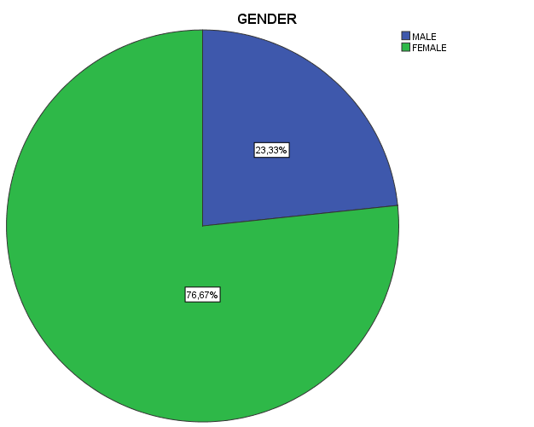
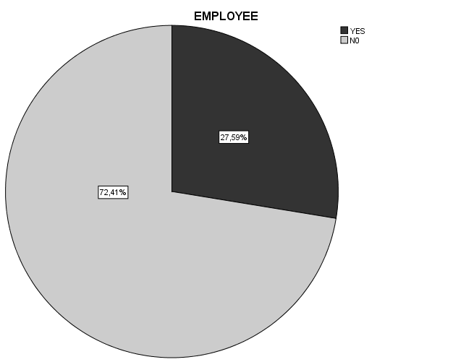

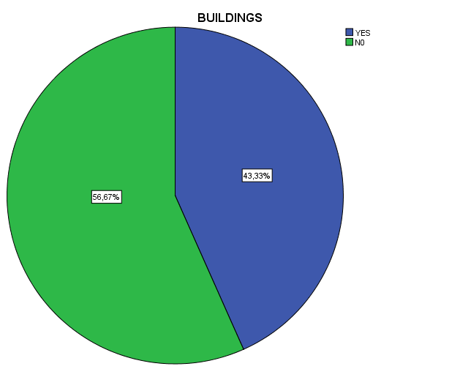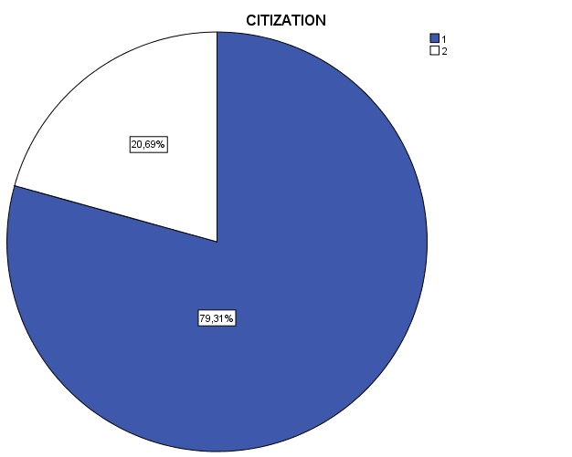

We then apply Variance Analysis. The dependent variable is the amount of WTP. Independent variables are the nominal variables of the questionnaire.
Tests of Between-Subjects Effects
Dependent Variable:V5
Source | Type III Sum of Squares | Df | Mean Square | F | Sig.
Corrected Model | 864362,990ª | 4 | 216090,748 | 1,565 | ,219
Intercept | 804100,165 | 1 | 804100,165 | 5,824 | ,025
V1 | ,000 | 0 | . | . | .
GENDER | 371588,518 | 1 | 371588,518 | 2,691 | ,115
EMPLOYEE | 372,135 | 1 | 372,135 | ,003 | ,959
CITIZATION | 15076,127 | 1 | 15076,127 | ,109 | ,744
BUILDINGS | 239636,982 | 1 | 239636,982 | 1,736 | ,201
Error | 3037325,306 | 22 | 138060,241
Total | 4839504,000 | 27
Corrected Total | 3901688,296 | 26
a. R Squared = ,222 (Adjusted R Squared = ,080)

We observe that the WTP is not affected by any of the above variables (sex, work, residence and possession of the property) at 5% significance level.

There is dependency by age. Participants, according to age class, accept to participate financially (WTP) in the regeneration of facades as shown in the following chart. The classes are: 1: 18-25, 2: 26-35, 3: 36-45, 4: 46-55, 5: 56-65, 5: more than 65 y.o.

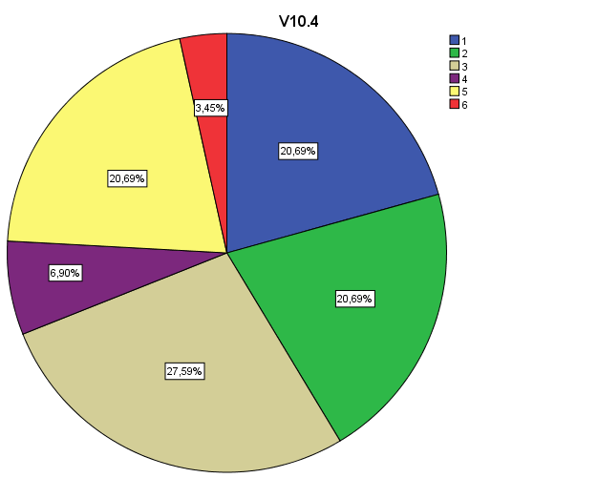

From the linear regression analysis the following can be deduced:
We note that the coefficient of determination of the regression model where the dependent variable is WTP and the other identities from all other questions in the questionnaire are taken as independent variables is 0.853. Therefore the adjustment of the model is quite good.
According to the Kendall index we observe that the WTP is positively correlated with the volunteer work of the respondent for reconstruction of the facade, at a significance level of 5% (P-value = 0.027, r = 0.321) and the correlation is moderate. It appears that as the voluntary work of the respondent for redevelopment of the façade increases, so does the amount WTP as well.
Question: In an effort of the Municipal Authority in restoring the external of buildings and the absence of available financial resources, we make the assumption that citizens are asked to participate financially in a special account. In this case, how much you would you be willing to contribute?
Average value: 19.71 €

We observe that the WTP is positively correlated with the contribution of the respondent to the account for the improvement of facades in Athens at 1% level of significance (P-value = 0.000, r = 0.692) and the correlation between them is strong. It appears that the more the contribution of the respondent to the account for the improvement of facades in Athens, the greater the WTP amount.

Question: Do you consider that effective treatment of aesthetic degradation will substantially benefit those who are active professionally on the area?
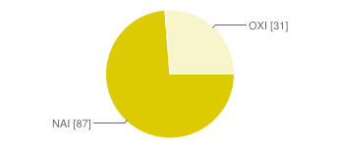 | YES 87 73%  NO 31 26%

Question: What is the significance for you in general of the impact of environmental rehabilitation works (natural and urban) in the current economic situation?
- Great 39%
- Moderate 37%
- Some 22%
- Insignificant 3%

Question: Do you have a practical benefit from a concerted effort by the municipality and citizens to address the aesthetic pollution;
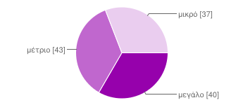 | Great 33%  Moderate 36%  Small 31%

Question: Educational level of respondents:

Primary school 1%
Gymnasium 7%
High School 29%
College Degree 41%
Postgraduate studies 23%
