WILLINGNESS TO PAY METHOD FOR MEASURING THE EXTERNAL COST OF NOISE POLLUTION
¹ ODYSSEAS KOPSIDAS

¹ School of Economics and Busssiness, Neapolis University Paphos, 2 Danais Avenue, 8042, Paphos, Cyprus, tel: 357 26843300, e-mail: odykopsi@yahoo.gr

Abstract: The purpose of this study is to evaluate the environmental benefit of reducing noise pollution and express the benefits in monetary units using the technique of ‘Contingent Valuation Method’ (CVM). Until now, the sound protection technology was paid by the citizens through taxation. As the evaluation of the environmental benefit i.e. public good cannot be expressed by market forces, a modified version of the Contingent Valuation Method was applied. With the scope of determining valuable feedback from the interviewees, we intend to examine how the citizens are willing to pay for the related expansion of noise barriers (WTP) along the regional highway of Thessaloniki in Greece. Questionnaires were distributed to residents in areas located along the peripheral highway of Thessaloniki and processing of responses was done using the SPSS - Statistics. Measurements were made with a sound level meter after noise barriers were installed along the regional highway of Thessaloniki to calculate the noise reduction levels. The measurements showed that in areas where there were noise barriers, noise was reduced to about approximately 1/3 compared with no noise barriers. It is proposed three alternative business models for noise reduction which are all responsible and taking into account the total macroeconomic social welfare.
Keywords: environmental benefit, public good, CVM, questionnaire, noise, noise barrier, sound level meter

1. INTORODUCTION
The noise pollution caused by vehicles traveling on the ring road of Thessaloniki in Greece was conducted using noise measuring tools that provided the data associated with Experimental Economics. Using that evaluation data we propose to develop a teaching method on the environment and to calculate the total benefit to the residents who live near and around the highway (Barbier, E.B, 1993).
Experimental Economics, as a branch of Economic Science, has traveled a similar path to that of general economic theory from at least the 18th century (Baron MG, and all, 1997). Each resource alone or in combination with others can be used in alternative ways. The potential problem that arises is how natural resources are distributed optimally (Bohm, P., 1972). Thus, the authors believe that the problem of the environmental cost of noise pollution is basically studied by Microeconomic Theory and its investigation involves the use of basic concepts and analytical tools of Neoclassical Microeconomic Theory (Brouwer, R., and all, 2003).
The basic idea of the valuation of environmental goods, as in the sound protection barriers, is based on the preferences of individuals (or householders) in relation to the environment, and the willingness to pay for the public good. The option is either to enjoy the environmental good or alternatively to accept the loss of this environmental good (Brouwer, R., and all 1999). The economic concept of value has been the foundation of the Neoclassical Theory of Economic Welfare (Welfare Economics) (Carson, R.T., Mitchell, R.C., 1993). Welfare Economics is based on the consideration and purpose that any economic activity is to increase prosperity (well- being) of each person in society, and that the citizen is best suited to decide on such matters himself (Coller, M. and Harrison, GH, 1995).
The benefit that each person receives, depends on the consumption of private goods and the use of state services because a large percentage of the citizenry are making decisions on non-tradable goods and services based on the quantity and quality of the public goods that results from the environment itself (Philip Coopera and all, 2004). The criteria which shows the valuation of some goods and the cost of some changes in the natural environment is whether they will affect human welfare or not (Cropper, M.L. and Oates, W.E., 1992).
2. METHODOLOGY
All the measurements were made with a special sound meter in situ and followed the same steps. The measurements were made under the same conditions so that there is uniformity in the results. The CASELLA, CEL 440 sound level meters, was placed at a height of 1.5 meters from the ground. The sound level meter was positioned parallel to the ground and the microphone directed on the road. During the experiment the traffic measurements of the background value caused by cars when driven at an average speed of about 70km/h included the number of vehicles passing through the measurement point every minute. The results are listed in the tables below and illustrated in the relevant diagrams.
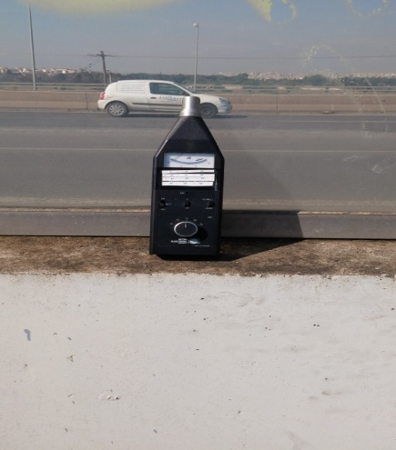
Fig.1. CASELLA, CEL 440 sound level meters
Table 1: The results of the measurements to the point without noise barrier
α/α | t (min) |  | I (db) |  |  | I (db) real | N (cars)
1 | 0 |  | 7 |  |  | 57 | 65
2 | 2 |  | 5 |  |  | 55 | 61
3 | 4 |  | 18 |  |  | 68 | 57
4 | 6 |  | 14 |  |  | 64 | 78
5 | 8 |  | 10 |  |  | 60 | 103
6 | 10 |  | 7 |  |  | 57 | 80
7 | 12 |  | 11 |  |  | 61 | 103
8 | 14 |  | 10 |  |  | 60 | 80
9 | 16 |  | 8 |  |  | 58 | 69
10 | 18 |  | 8 |  |  | 58 | 65
11 | 20 |  | 7 |  |  | 57 | 84
12 | 22 |  | 5 |  |  | 55 | 69
13 | 24 |  | 18 |  |  | 68 | 68
14 | 26 |  | 14 |  |  | 64 | 61
15 | 28 |  | 10 |  |  | 60 | 57
16 | 30 |  | 7 |  |  | 57 | 78
17 | 32 |  | 11 |  |  | 61 | 103
18 | 34 |  | 10 |  |  | 60 | 80
19 | 36 |  | 8 |  |  | 58 | 103
20 | 38 |  | 8 |  |  | 58 | 80
21 | 40 |  | 8 |  |  | 58 | 69
22 | 42 |  | 6 |  |  | 56 | 65
23 | 44 |  | 16 |  |  | 66 | 84
24 | 46 |  | 15 |  |  | 65 | 69
25 | 48 |  | 9 |  |  | 59 | 68
26 | 50 | 8 |  | 58 | 61
27 | 52 | 10 |  | 60 | 57
28 | 54 | 10 |  | 60 | 78
29 | 56 | 9 |  | 59 | 103
30 | 58 | 8 |  | 58 | 80
31 | 60 | 7 |  | 57 | 103
32 | 62 | 8 |  | 58 | 80
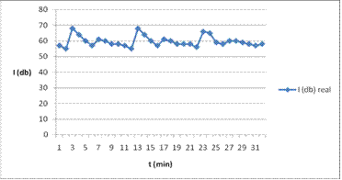
Fig. 2. Diagram showing the volume (I) as a function of time (t) to point without noise barrier
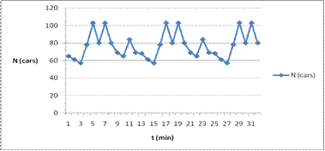
Fig. 3. Diagram showing the number of passing vehicles (N) as a function of time (t) to point without noise barrier
Table 2: The results of the measurements to the point with noise barrier
α/α | t (min) | I (db) | I (db) real | N (cars)
1 | 0 | -1 | 49 | 90
2 | 2 | 3 | 53 | 110
3 | 4 | 2 | 52 | 62
4 | 6 | 5 | 55 | 74
5 | 8 | 7 | 57 | 66
6 | 10 | 2 | 52 | 110
7 | 12 | 3 | 53 | 73
8 | 14 | 2 | 52 | 125
9 | 16 | 1 | 51 | 75
10 | 18 | 4 | 54 | 115
11 | 20 | 8 | 58 | 94
12 | 22 | -2 | 48 | 82
13 | 24 | 5 | 55 | 88
14 | 26 | 3 | 53 | 75
15 | 28 | -1 | 49 | 76
16 | 30 | 3 | 53 | 86
17 | 32 | -1 | 49 | 110
18 | 34 | 3 | 53 | 62
19 | 36 | 2 | 52 | 74
20 | 38 | 5 | 55 | 66
21 | 40 | 7 | 57 | 110
22 | 42 | 2 | 52 | 73
23 | 44 | 3 | 53 | 125
24 | 46 | 2 | 52 | 75
25 | 48 | 1 | 51 | 115
26 | 50 | 4 | 54 | 94
27 | 52 | 8 | 58 | 82
28 | 54 | -2 | 48 | 88
29 | 56 | 5 | 55 | 75
30 | 58 | 3 | 53 | 76
31 | 60 | -1 | 49 | 86
32 | 62 | 3 | 53 | 85
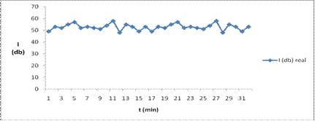
Fig. 4. Diagram showing the volume (I) as a function of time (t) at a point with noise barrier
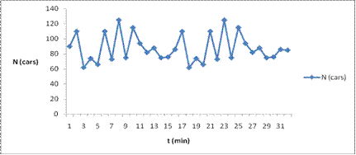
Fig. 5. Diagram showing the number of passing vehicles (N) as a function of time (t) at a point with noise barrier
There are observed the differences between Fig. 3 and Fig. 5. In Fig. 3 the measurements were made without noise barriers whereas in Fig. 5 the measurements were made using the sound protection offered by existing road noise barrier technology.
3. IMPLEMENTATION
The results show that the average level of noise intensity is above the permissible values. The main question put to the interviewees was, what is the maximum amount of monetary units they are willing to pay (WTP) for noise barriers along the regional road of Thessaloniki. The interviewees were asked what is the maximum amount they are willing to pay to create a common fund in order to finance the noise protection barriers in the specified area given the fact that the government is not currently financially viable to undertake the such a project. The average response to the questionnaire was 10.5 euros per interviewee. From the measurements undertaken we concluded that the use of appropriate noise barriers can reduce the noise caused by passing vehicles along the regional road of Thessaloniki up to 1/3 of the original value, i.e. the measurement without the noise barriers. Therefore, the potential benefit to the citizens in the expressed area is significant. There are observed the citizens’ responses after providing them the measurements with and without noise barriers.
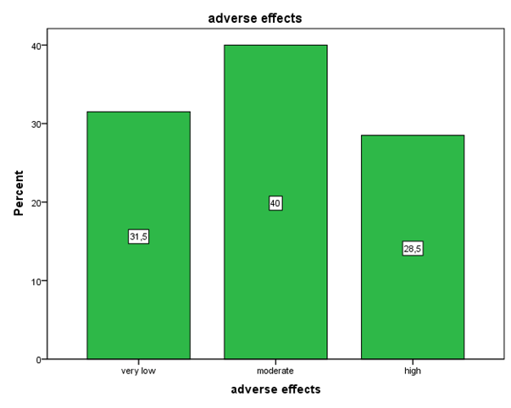
Fig. 6. Bar graph level of noise impact
Fig. 6 depicts that 31.5% of the interviewees believe that the adverse effects of noise pollution near the road is very low, 40% thought it was moderate while 28.5% believe that it is high.

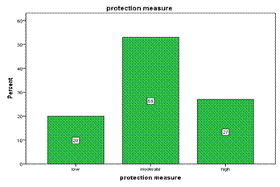
Fig. 7. Bar graph for noise protection measures taken by the Government
Fig. 7 depicts that 20% of the interviewees consider that the measurements taken by the authorities to protect areas from noise pollution caused by specific routes is negligible, 53% of interviewees believe that the noise pollution is modest and 27% of interviewees believe that it is high.
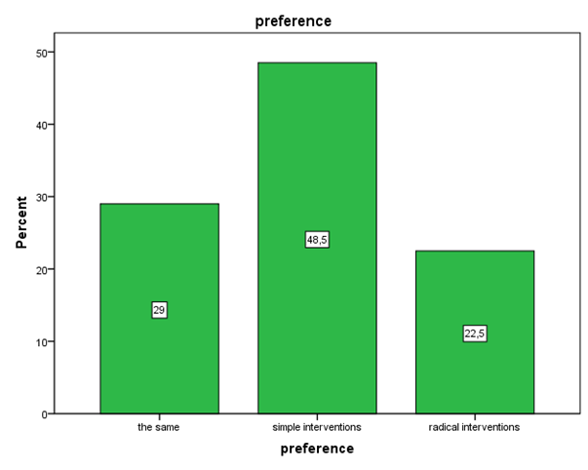
Fig. 8. Bar graph for alternatives solutions suggested by interviewees
It is noted that 29% of the interviewees would like to leave the situation as is, 48.5% would like to make minimal changes, while 22.5% of respondents would like to make whole shell improvements.
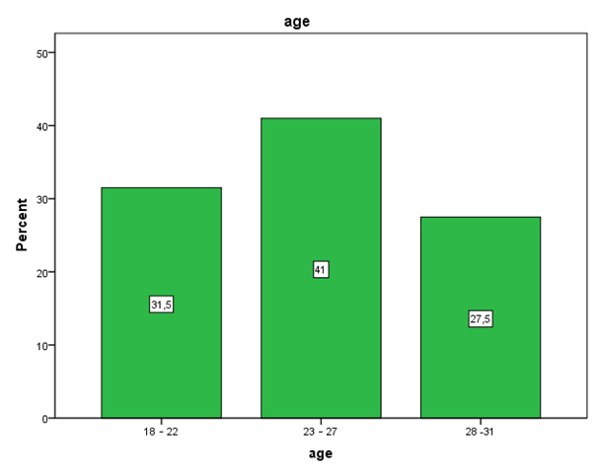
Fig. 9. Bar graph on the age group of the interviewees
Therefore, it is presented some demographic data of the interviewees. According to Fig. 9, it is seen that 31.5% of interviewees were aged between 18-22 years old, 41% were aged between 23-47 years and 27.5% were aged between 28-31 years.
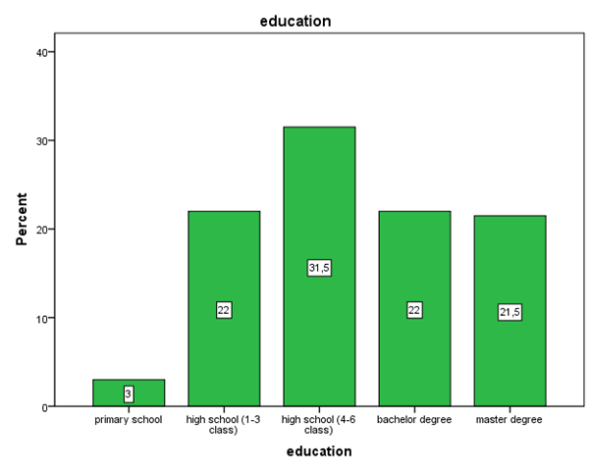
Fig. 10. Bar graph of the education level of the interviewees
In Fig. 10, it is seen that only 3% of the interviewees attended primary school, 22% have finished 3 years of high school, 31.5% have finished 6 years of high school, 22% of interviewees have university or technological studies and 21.5% of the interviewees have postgraduate studies.
4. CONCLUSION
There are three basic business models that can be examined for funding and implementing sound barriers technology. The first business model is where the Government totally funds the project by borrowing money from private financial institutions hence increasing the national debt or raising revenue from increased taxes. The second business model is where the project is funded by the citizens on their willingness to pay for the public good. The third business model provides an opportunity for private industry to implement the necessary infrustacture based on an advertising model where profits are generated by selling advertisement space that is available on the sound barriers. This solution has an opportunity cost where aesthetic pollution is moved from one location to another. Furthermore, there is an opportunity for Government and private industry to collaborate.
The potential benefits from noise barriers provide improved living conditions and increase property values, this in turn will provide additional revenue to the Government, as the property is taxed at a higher value. Private companies that will allocate funds to the project will benefit as being seen as environmentally conscious and environmentally responsible. The noise barriers can be used by advertisement companies to sell advertisement space. The revenue generated from the advertisement space will pay for the noise barriers, installation and maintenance.
This solution provides a benefit to all parties involved. The municipality and the Federal Government will have a huge political benefit as a partner with private industry in the development of environmentally friendly infrastructure. An additional benefit to the Government and taxpayer is a saving in healthcare costs as there is a less strain on the healthcare system. Moreover, the sound reduction barriers maximize social welfare after limiting the environmental costs.
This work contains a framework for cooperation between the private and public sectors that potentially can generate multiple benefits without heavily impacting any social group or the environment. Also, this work combines the Marketing and Management of Natural Resources with the fundamental issues related to Public Economics and its Administration. Moreover, as argued by V. Pareto - an activity is beneficial to society when it improves the economic situation of certain individuals, without correspondingly worse socioeconomic status of others. Then the activities of people tend to maximize social welfare.
RERERENCES
1. Barbier, E.B, “Sustainable Use of Wetlands – Valuing Tropical Wetland Benefits: Economic Methodologies and Applications”, The Geographical Journal, vol. 159, no.1, 1993.
2. Baron, M. G, Zaitsev N, Schechter M., “Expected recreational benefits of the Hula project: Economic analysis Final report to the Hula Project Authority”, 1997.
3. Bohm, P. “Estimating demands for public goods: An experiment. European Economic Review”, 3, pp. 11-30, 1972.
4. Brouwer, R., Langford, I., Bateman, I., Turner, R.K., ‘A meta-analysis of wetland ecosystem valuation studies”, Chapter 5 in Turner, R.K., Jeroen, C., van den Bergh, J.M., 2003.
5. Brouwer, R., Langford, I.H., Bateman, I.J., Crowards, T.C. & Turner, R.K.., “A metaanalysis of wetland contingent valuation studies”, Regional Environmental Change 1, 47- 57, 1999.
6. Carson, R.T., Mitchell, R.C., “The value of clean water: the public’s willingness to pay for boatable, fishable, and swimmable quality water”, Water Resources Research 29 (7), pp. 2445–2454, 1993.
7. Coller, M., Harrison, G.H., “On the Use of the Contingent Valuation Method to Estimate Environmental Costs”, In: Advances in Accounting. Reckers, P.M.J. (ed.), Greenwich, CT: JAP Press, volume 13, 1995.
8. Coopera,P. , Poeb,G. L. Bateman I. J. “The structure of motivation for contingent values: a case study of lake water quality improvement”, Ecological Economics 50 (2004) pp. 69– 82, 2004.
9. Cropper, M.L. and Oates, W.E. , “Environmental Economics: A survey. Journal of Economic Literature”, Vol. XXX, pp. 675-740, 1992.

